**SWE 7903**

Release Management Application (RMA)

Team # 3

*Chloe Lincoln, Raghuram Banda, Shamira Bright, Phillip DaCosta, Young Chung*

***Gas South***

**User Manual**

Contents

1. Overview 3

2. Purpose 3

3. Master Calendar Page 3

4. Active Projects Page 5

5. Completed Projects Page 6

6. Login 7

7. Your Projects Page 8

8. Profile Page 10

9. Manage Users Page 12

10. Create User Page 14

11. Logout 16

12. Helpdesk 16

# 1. Overview

Release Management Application (RMA) is intended to be a high-level visual application for the business side of Gas South. It will also provide requested information on a project to the project team and allow Project Managers to better schedule their release dates.

This application is not meant to replace the current Project Management Tool, Innotas. Instead, it is to simplify the information contained in Innotas and to provide information that will be useful for every project.

# 2. Purpose

The purpose of this document is to provide a detailed outline of the application, which includes all features, user access, and the helpdesk procedures. This document will break down each feature the application offers the user.

# 3. Master Calendar Page

The Master Calendar page serves as the company’s visual aid into US Holidays, India Holidays (for our offshore team), and Project Releases. The views that are available are: Month, Week, and Day. You are able to navigate to previous and future pages of the calendar as well as an option to return to Today’s date.

This calendar is a read-only calendar. Manual event adding has not been implemented. However, the user is able to toggle between the US Holidays, India Holidays, and Project Releases.

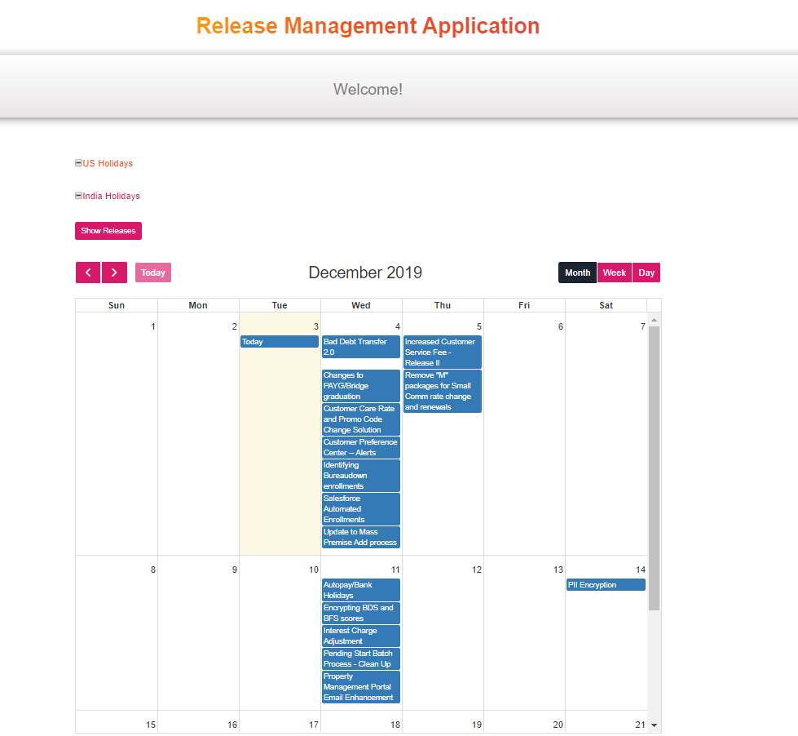

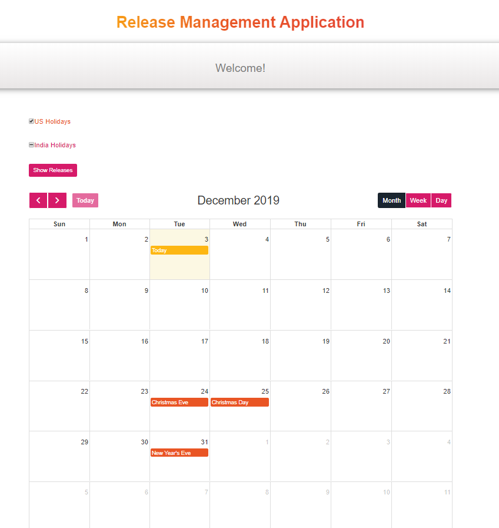

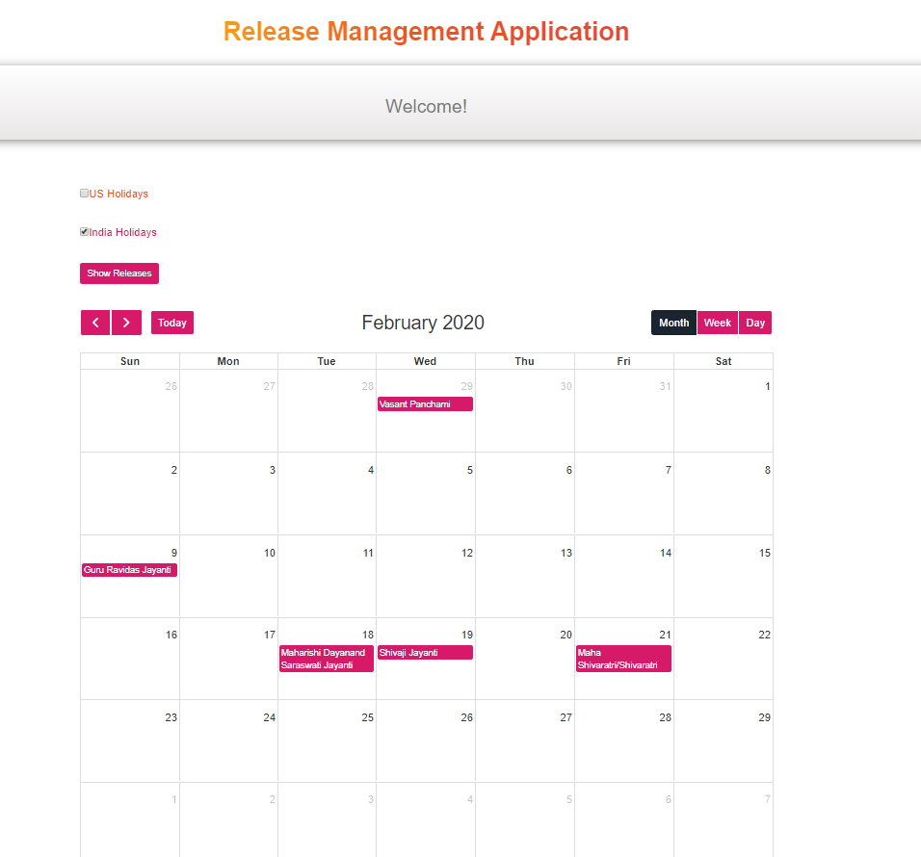

All user types have access to view the Master Calendar.

# 4. Active Projects Page

The Active Projects page provides the company a list of all projects in “Open” and “Hold” status. The page will initially display a list of all projects with the above criteria, which then can be expanded to display more information about the project. The information that will display is:

1. Release Name
2. Release Start Date
3. Go Live Date (will display “TBD” if the value is null)
4. Project Status
5. RYG Status (will not display if there is no value)
6. Project Manager
7. Product Owner
8. Business Analyst
9. QA
10. Test Environment

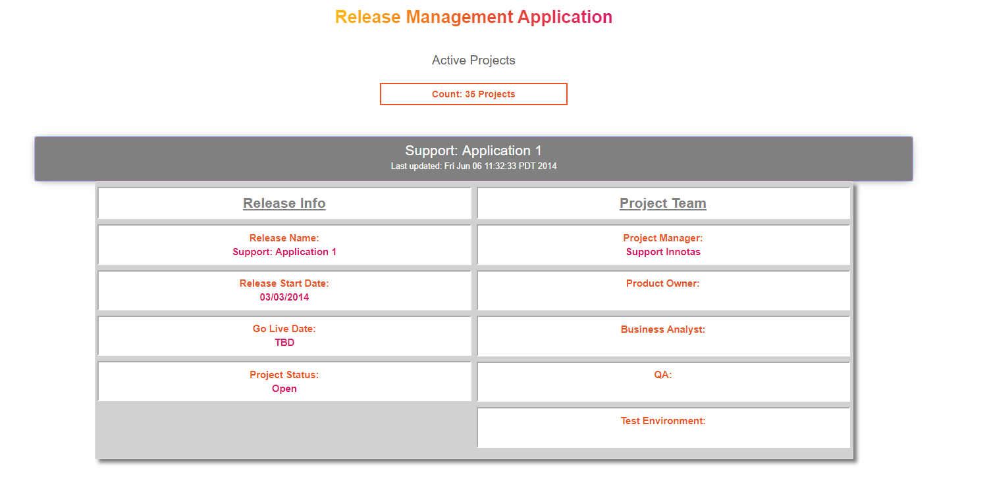

All user types have access to view the Active Projects Page

# 5. Completed Projects Page

The CompletedProjects page provides the company a list of all projects in “Completed” status. The page will initially display a list of all projects with the above criteria, which then can be expanded to display more information about the project. The information that will display is:

1. Release Name
2. Release Start Date
3. Go Live Date (will not display if there is no value)
4. Project Status
5. RYG Status (will not display if there is no value)
6. Project Manager
7. Product Owner
8. Business Analyst
9. QA
10. Test Environment

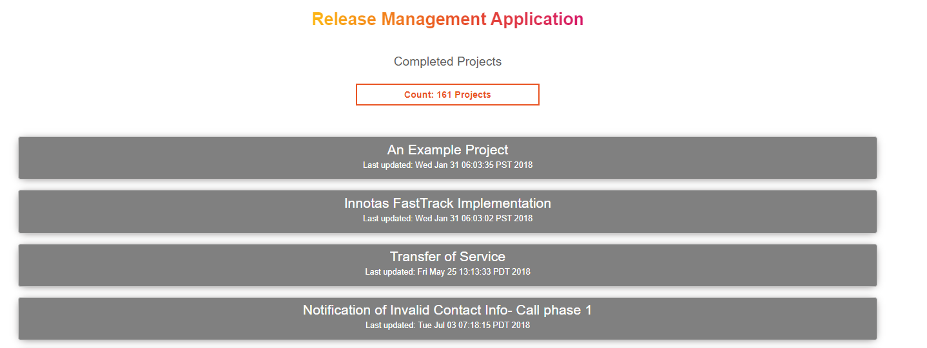

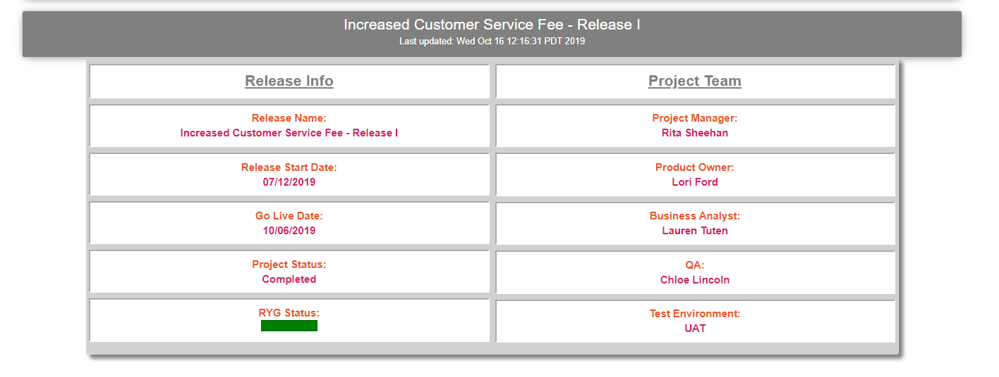

All user types have access to view the Active Projects Page

# 6. Login

The login page is for users who have credentials only. This primarily consists of the PMO team. The business will not have any users in the system and will be considered a “guest” only. This allows users who have credentials to access other pages within the application (i.e. Your Projects page, Manage Users page, Profile page).

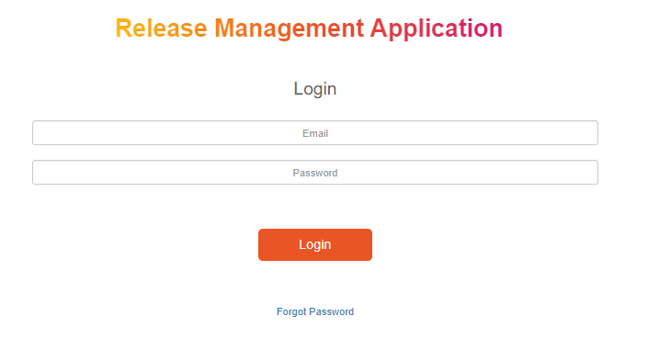

There is also a “Forgot Password” feature. If you are a user in the application with credentials, you will be able to request a password reset. An email will be sent containing the information you need to be able to login to your account.

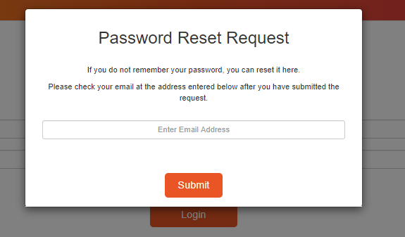

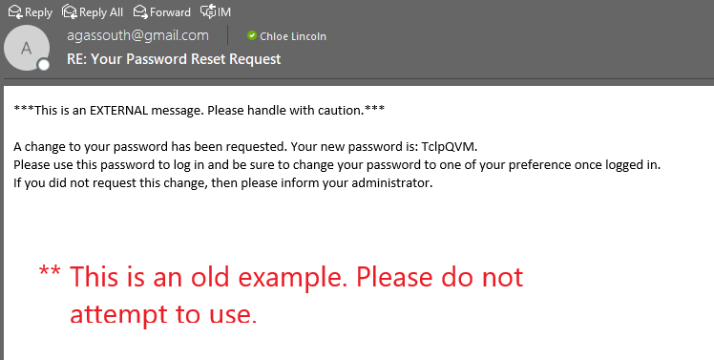

Should a user provide invalid credentials, an error message will display. Your credentials will be your work email and password. You will have to be added to the application by an admin of the application. Please refer to the helpdesk section for more information.

Only users with credentials and admins will be able to use this page.

# 7. Your Projects Page

The Your Projects page lists all projects the user was a Project Manager on. Any projects with the status “Cancelled” will not display. This page also allows the user to add team members to the project. This input will be displayed on the projects on the Active Projects page and the Completed Projects pages. If a user has never been a Project Manager on a project, the user will see the message “No Projects to Display”

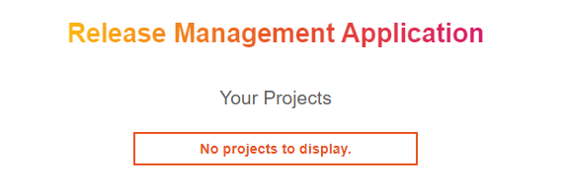

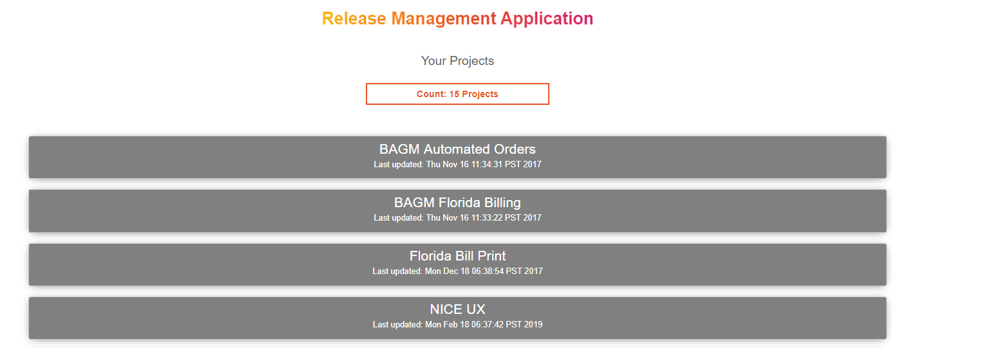

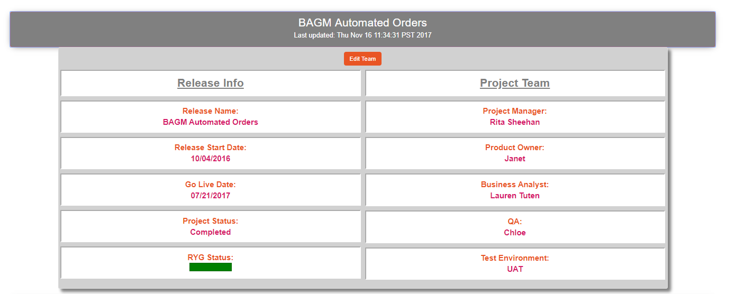

To add a team member to the page, click on “Edit Team” button. A modal pop-up will display, then fill in the names for the existing positions:

1. Product Owner
2. Business Analyst
3. QA
4. Test Environment

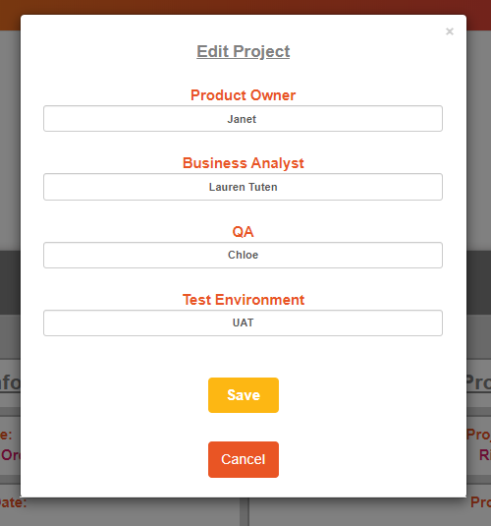

The user can click “Save” to save the names they entered. This page is only accessible to users and admins who have logged into their account.

# 8. Profile Page

The Profile page is for users and admins to be able to edit their own information. The information that can be edited on this page:

1. Firstname
2. Lastname
3. Email
4. Password

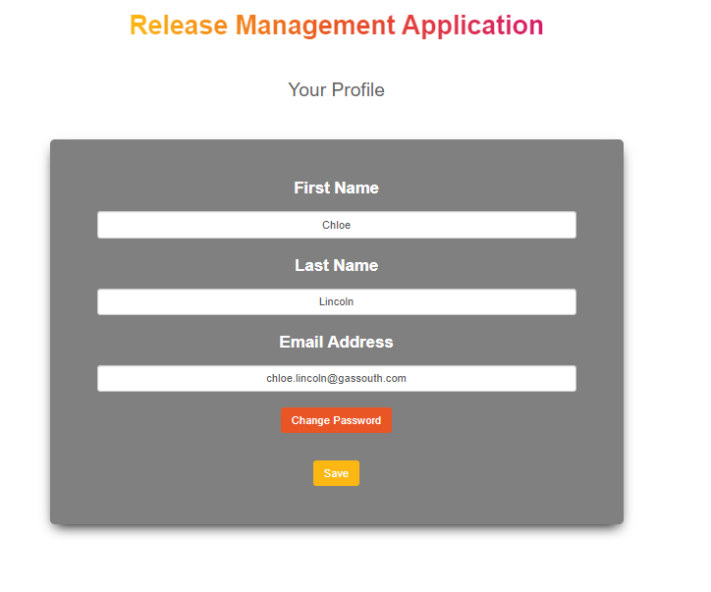

The first 3 fields can be edited without confirmation. They can edit the field and click “Save” which will save the new information. However, in order for the user to change their own password, they must confirm their current password. This can be done once the user selects “Change Password”.

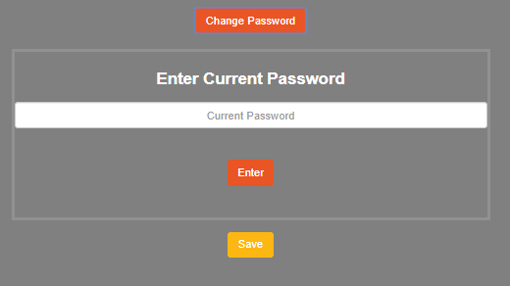

Once confirmed, the user can enter their new password. This also needs to be confirmed as well.

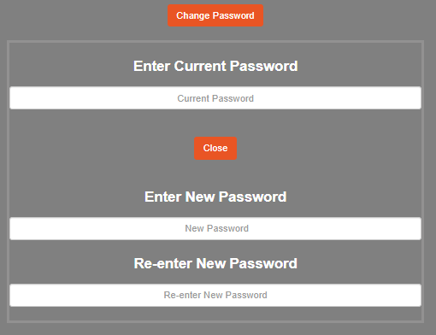

Once both password fields have been entered correctly, the user can then save the new password with the “Save” button.

# 9. Manage Users Page

The Manage Users page is for admins to update current users in the application. The admin can update the following pieces of information:

1. Firstname
2. Lastname
3. Email
4. Innotas ID
5. Password
6. User Rights- Dropdown Menu (Admin or User).

To edit a user, the Admin but first access the Manage Users page. Once there, a list will display.

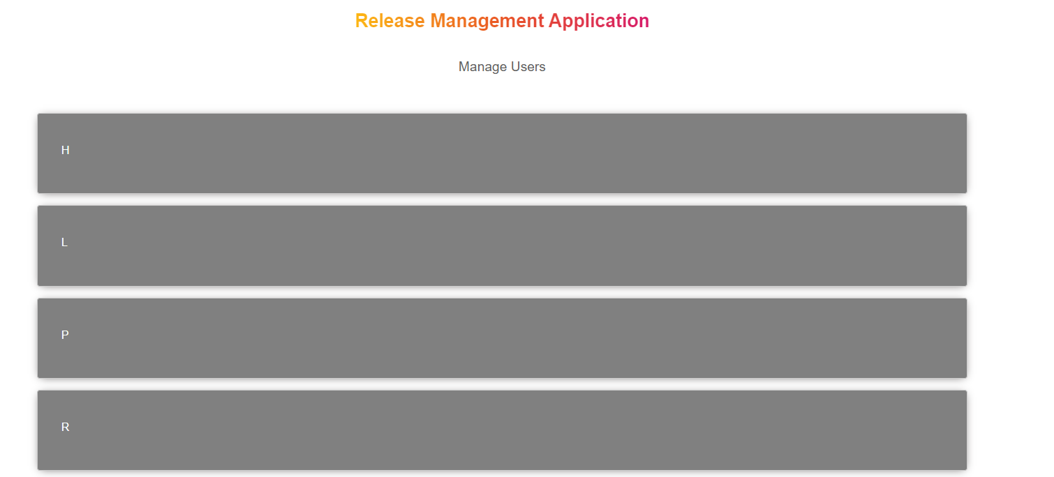

The admin can click on one of the following blocks, to expand the information and display users. Each user can be edited by clicking the “edit” button.

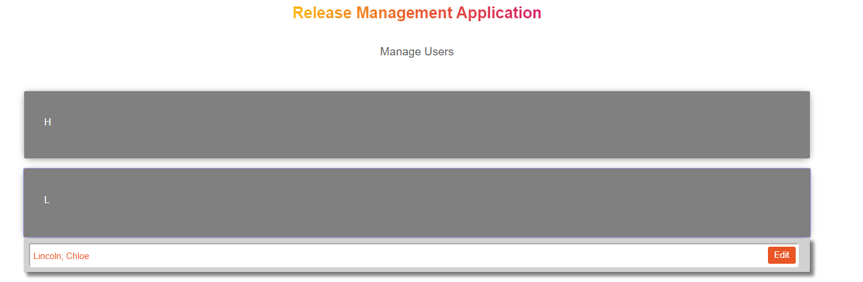

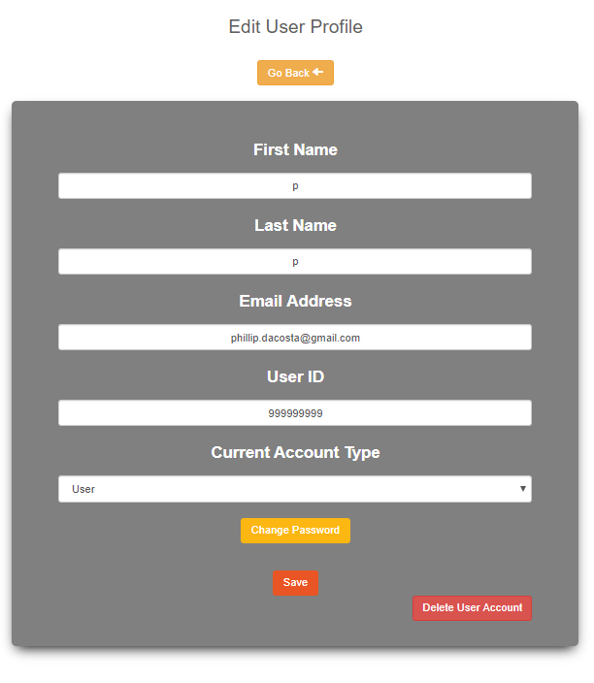

Once the admin has edited the field they desire, they will be able to click “Save” which will save all the changes made. In order to change a password, the admin will need to click on “Change Password” first.

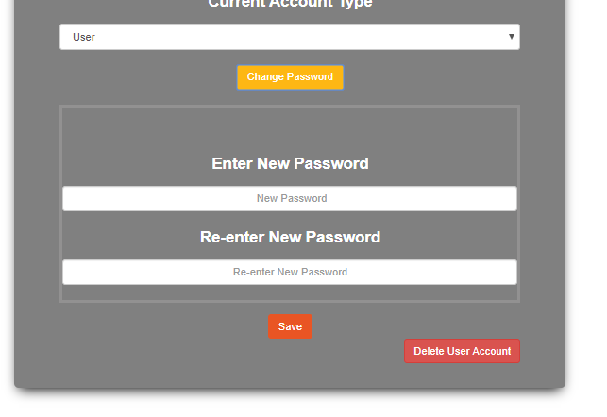

The admin can now change the password then click “Save” to save the new password. In the image above, there is also a “Delete User Account” button. This button will delete the user. This action cannot be undone, therefore a modal pop-up with a confirmation message will display. The admin must confirm that they really would like to delete the user.

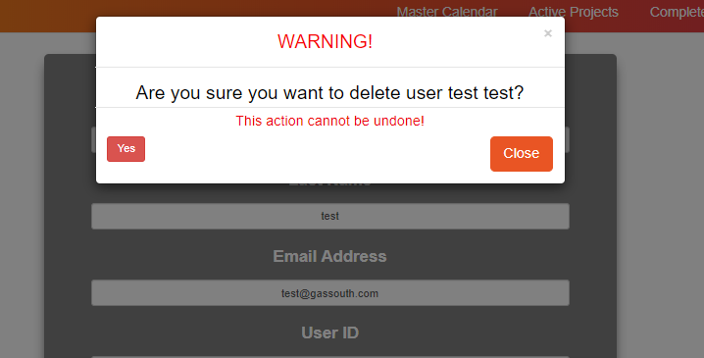

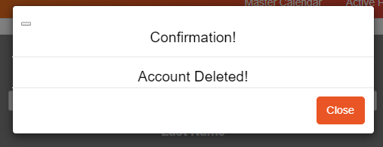

If the admin selects “Yes”, another modal pop-up will display. Once the admin clicks “Close”, it will redirect them back to the main part of the Manage Users page. Only those with admin credentials have access to this page and can edit users.

Please note, an admin cannot edit their own information from this page. They can edit their own information from the Profile page.

# 10. Create User Page

The Create User page is for admins to add new users with credentials to the application. Here the admin will be able to add information to these fields:

1. Firstname
2. Lastname
3. Email
4. Innotas ID
5. Password
6. Set User Rights- Dropdown Menu (Admin or User)

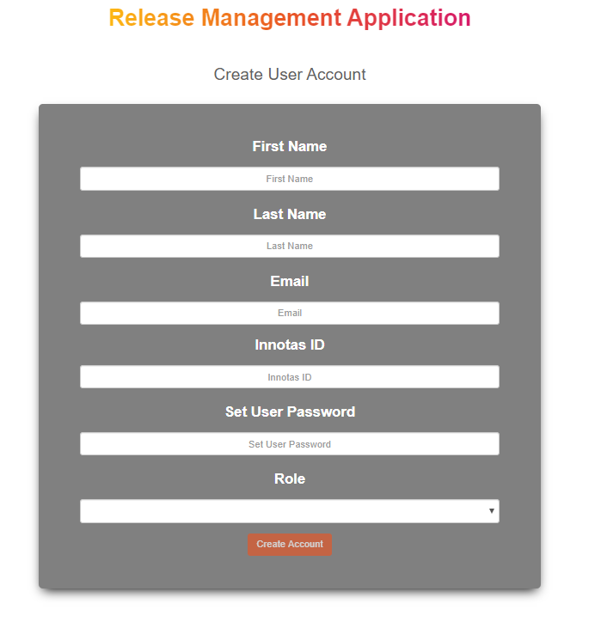

Once the information has been filled out, the admin will click “Create Account” button. A modal pop-up will display to confirm that the user has been created.

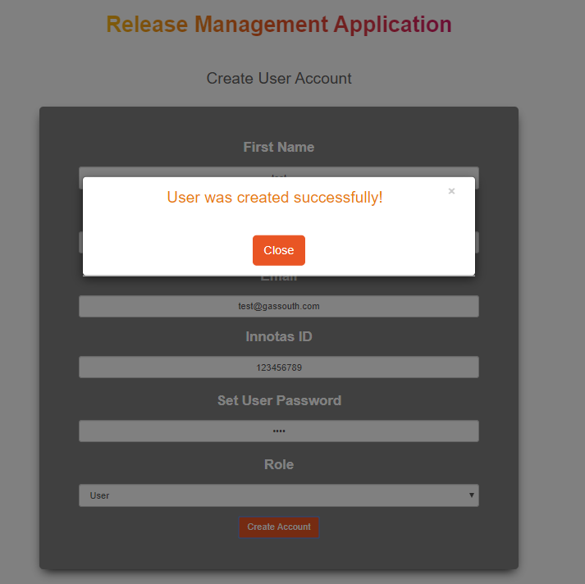

Once the admin clicks “Close”, the form will clear and the admin can continue adding more users. This is only accessible to users with Admin credentials.

# 11. Logout

If you are a user with credentials, and you are done using the application, you can manually log yourself out by clicking “Logout” button in the header. A modal pop-up will display asking for you to confirm that you would like to logout. However, if you do forget to logout manually, the application will timeout and automatically log you out after 30 minutes.

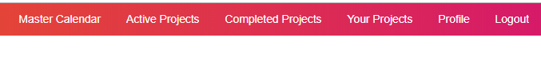

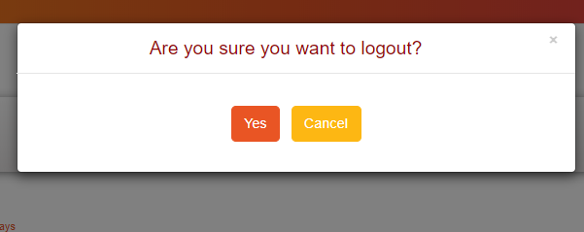

# 12. Helpdesk

There are currently 4 admin in the application. They are:

1. Myron Holder: [myron.holder@gassouth.com](mailto:myron.holder@gassouth.com)
2. Chloe Lincoln: [chloe.lincoln@gassouth.com](mailto:chloe.lincoln@gassouth.com)
3. Nadeem Fatmi: [nadeem.fatmi@gassouth.com](mailto:nadeem.fatmi@gassouth.com)
4. Salome Maina: [salome.maina@gassouth.com](mailto:salome.maina@gassouth.com)

If you encounter a bug or a system issue, please reach out to Chloe Lincoln. If you are having difficulty resetting your password with the “Forgot Password” feature, please reach out to any of the 4 admins above.

Please be aware that any emails from the “Forgot Password” feature are not monitored. Please do not reply to those emails, as no one will respond back.